**GAZIANTEP UNIVERSITY**

**FACULTY OF ENGINEERING**

**DEPARTMENT OF INDUSTRIAL ENGINEERING**



**GRADUATION PROJECT**

**Weighting the Factors Affecting Quality in Medical Sector with Dematel Method**

**PREPARED BY ;**

**AHMET KEMAL GURBET-190107011046**

**BÜŞRA ŞEKER-190114012052**

**ÖZKAN PERÇİN-200114012062**

**ARALIK 2024**

**ADVISOR ;**

**DR. ÖĞR. ÜYESİ PINAR KOCABEY ÇİFTÇİ**

**We hereby declare that all information in this document has been obtained and presented following academic rules and ethical conduct. We also declare that, as required by these rules and conduct, We have fully cited and referenced all material and results that are not original to this work.**

**AHMET KEMAL GURBET**

**BÜŞRA ŞEKER**

**ÖZKAN PERÇİN**

**ABSTRACT**

Critical importance aside, the level of operations in the medical sector is achieved in terms of quality, patient safety, operational efficiency, and patient satisfaction. This study is conducted to identify the factors affecting quality and analyze the importance degrees of those factors. In this study, the DEMATEL method was used to assess the effect-cause relationship among the factors. According to the analysis made by DEMATEL analysis, the major factors like - personel eğitimi ve süreç standardizasyonu or -were found to be the most effective on the quality. The findings provide concrete suggestions for improving quality management systems in the medical sector.

**CONTENTS**

**ACKNOWLEDGEMENT…………………………………….…………8**

**1. INTRODUCTION…………………………………………….……….9**

**Literature Review ………………………………………………………10**

**What is Quality?..............................................................................10**

**History of the Concept of Quality ……………………………….10**

**Quality in the Healthcare Sector ……………………...…………11**

**Factors Affecting Quality in the Medical Sector ……….………11**

**1. Material Selection and Biocompatibility …………………………………...……11**

**1.1 Classification of Biomaterials ……………………………………………11**

**1.2 Factors to Consider in Material Selection …………………..13**

**2) Device Calibrations …………………………………………..………13**

**3) Machine Maintenance ……………………………………….……….14**

**4- Personnel Performance and Training ………………………………15**

**4.1 The Impact of Personnel Performance on Quality …………………….15**

**4.2 The Impact of Training on Quality ……………..………………...…….16**

**4.3 The Impact of Occupational Health and Safety Practices …..……...…16**

**4.4 Performance-Based Payment Systems………………………......………16**

**5- Total Quality Management and Continuous Improvement (Kaizen) ………....16**

**5.1 Continuous Improvement ………………………………………………..16**

**5.2 Leadership and Management Support……………………….………….17**

**5.3 Customer Focus……………………………………...……………………17**

**5.4 Process Management……...……………...………………………………17**

**6- Compliance with Regulations and Standards……………..……….17**

**6.1 International Standards………………………………………………….17**

**6.2 Quality Management Systems……………………………………………17**

**6.3 Risk Management…………………………………………………………18**

**6.4 Compliance with Regulations……………………………...……………..18**

**6.5 Clinical Evaluation and Post-Market Surveillance…………………….18**

**7- Patient Feedback and Clinical Outcomes…………………………..18**

**7.1 Patient Satisfaction Surveys……………………...……………...……….18**

**7.2 The Impact of Clinical Outcomes on Quality……………………...……18**

**8- Supply Chain Management……………………..……………………19**

**8.1 The Relationship Between Supply Chain Management and Quality.....19**

**8.2 Supplier Selection and Its Impact on Quality…………………….……..19**

**8.3 Process Management and Efficiency………………………………….…19**

**8.4 Customer Satisfaction and Quality Management………………..……..19**

**8.5 Improvement and Innovation………………………………...………….19**

**9) CAD-CAM Applications…………………………………………...…19**

**10) Quality Control Processes……………………………………….….20**

**11) Surface Smoothness and Osseointegration………………………...20**

**12) Product Sterilization and Cleanroom………………...……………21**

**12.1 Sterilization…………………………….…………………………...……21**

**12.1.1 Physical Sterilization……………………………………………..……21**

**12.1.2 Chemical Sterilization……………...………………………………….22**

**12.2 Cleanroom……………………..…………………………………………23**

**13) Environmental Hygiene…………………………………………….23**

**13.1 Personnel Hygiene………………………………………….……………23**

**13.2 Equipment and Material Hygiene………………..…………………….24**

**13.3 Equipment and Material Disinfection……………...…………………..24**

**13.4 Workplace Hygiene…………………………………………….………..24**

**14) R&D Activities………………………………………………….……24**

**15) Logistics………………………………………………………………25**

**15.1 Production Planning…………………………………………………….25**

**15.2 Material Management………………………………...……….………..25**

**15.3 Inventory Management……………………………...………………….25**

**15.4 Storage and Material Handling…………………...……………………26**

**15.5 Distribution………………………………………………...…………….26**

**15.6 Warehouses and Depots………………………………...……………….26**

**15.7 Transportation…………………………………..……………………….26**

**15.8 Insurance…………………………………………………………………26**

**15.9 Customs Services……………………………………….………………..26**

**15.10 Customer Services……………………………….……………………..26**

**15.11 Technical Support…………………………………………….………..26**

**16) Inspection and Testing………………………………………………27**

**17) Certification………………………………………………...………..27**

**18) Traceability……………………………………………………….….28**

**19) Clinical Collaboration and Survey Studies………………...………28**

**20) Use of Technology…………….……………………………………..29**

**Method……………………………………………………………..….….30**

**Use and Definition of the Relation Scale…………………..…….30**

**Table 1: Influencing and Influenced Criteria Matrix…………...………….30**

**Table 2: Normalized Relation Matrix…………………...…………………..32**

**Table 3: Identity Matrix and I,(I-M) Matrix……………………………………….33**

**Table 4: (I−M)^−1 Matrix…………………………………………………....34**

**Table 5: Total Relation Matrix……………………………………...……….35**

**Table 6: Identification of Importance Weights……………………………….36**

**Medical Sector Quality Influencing Factors and TheirWeighting…………...……37**

**Conclusion…………………………………………………………..……38**

**References………………………………………………………………..39**

**.**

**ACKNOWLEDGEMENT**

**We would like to thank our advisor Dr. PINAR KOCABEY ÇİFTÇİ for her guidance and support throughout the study. We are grateful for her encouragement and motivation.**

**Introduction**

The healthcare sector plays a critical role in improving the quality of life in societies and ensuring access to the necessary healthcare services for individuals. Technological innovations, scientific research, and advancements in healthcare policies continually propel the sector forward, enabling it to provide more efficient solutions. The success of healthcare services is directly related not only to the competencies of healthcare professionals but also to the quality of the tools, devices, and materials used. In this context, medical materials emerge as one of the fundamental building blocks of modern healthcare services.

Medical materials play a key role in enhancing the efficiency of healthcare services and are utilized in various stages, from diagnosis to treatment, rehabilitation, and surgical interventions. However, the quality and reliability of these materials depend not only on technological innovations but also on a broad spectrum of factors, ranging from production processes to the supply chain. Critical elements determining the success of medical materials include material selection, production conditions, compliance with standards, and patient feedback.

Production processes are a significant component influencing the quality of medical materials. The effective use of technology in these processes reduces costs while ensuring the production of products that meet international standards. In addition, personnel training plays a crucial role in maintaining quality continuity. Trained personnel minimize potential errors during the production process, thereby enhancing the effectiveness and reliability of the products.

Within the scope of quality management, continuous improvement efforts have become an indispensable element in the healthcare sector. Patient feedback, in particular, serves as a valuable data source to understand how medical materials perform during use and to make necessary improvements accordingly. Additionally, supply chain management is critical for ensuring the effective distribution of medical materials. Optimizing all processes, from raw material procurement to the final product reaching the end-user, contributes to controlling costs and maintaining product quality.

This study aims to delve deeply into the design, production, and utilization processes of medical materials, drawing from the general dynamics of the healthcare sector. It is anticipated that the study will offer innovative and sustainable solutions for the healthcare sector, providing valuable contributions to both academic and practical fields.

**Literature Review**

**What is Quality?**

Quality is derived from the Latin word "quails," which means "how it is formed." In the dictionary, it is defined as the feature or attribute of everything, suitability, excellence, superiority, or degree of perfection. The concept of quality is continuously evolving and developing. Numerous studies and definitions have been made on it.

Researchers and academics who have worked on the concept of quality have defined it as a judgment of the user or customer of goods and services, as well as the degree to which their needs and expectations are met. From an economic perspective, it has been expressed as the ability to provide goods and services that meet customer needs in the most suitable way.

**History of the Concept of Quality**

The concept of quality dates back to ancient times, as early as 2000 BCE, according to the first written historical records during the period of Ancient Egypt. It was found that terms related to quality were used in the Code of Hammurabi in 2150 BCE. Since ancient times, the sole arbiter acting as a quality control expert has been the customer who receives the product or service. By nature, humans desire to own the best product. For this reason, they have involved themselves in research and development processes in this field.

In Ancient Egypt, it is known that the surface of blocks was inspected with the help of ropes or wires. Today, quality is regarded as equivalent to the nature of work and achieving appropriate results by doing the job correctly. The Ahi guilds during the Seljuk period and the guild organizations during the Ottoman period can be cited as examples of quality management. The purpose of these professional organizations was to protect the rights of their members, foster cooperation, transfer the profession to new generations, establish standards for the profession, and enforce ethical rules and practices.

With the invention of machines during the Industrial Revolution, production shifted from workshops to factories, and new management challenges began to emerge. During this period, the scientific management school, formed by F. Taylor, H. Fayol, and F. & L. Gilbreth, sought to find the best methods of specialization and simplification. Meanwhile, the behavioral theory developed by researchers such as E. Mayo, M. Follett, D. McGregor, and A. Maslow led advancements in the field of quality management.

These efforts eventually laid the foundation for the Total Quality Management (TQM) approach. TQM initially gained prominence in the industrial sector and later became widespread in the fields of education and healthcare.(1)

**Quality in the Healthcare Sector**

Quality in health care is generally defined as the degree of excellence of service delivery or the degree of excellence of the service provided. In this context, quality service in healthcare means providing care at accepted standards, ensuring that patients and healthcare staff have equal opportunities to participate in service evaluation and planning processes, and maximizing patient safety and healthcare quality.

In line with your thesis topic, quality management and determining the factors affecting this quality have a critical role. Considering that health services are of a social nature, services should be provided equally to all members of the society, not only to a certain segment. In this context, factors such as staff training, process standardization, hygiene and sterilization, patient feedback and compliance with regulations become priorities in the provision of safe and quality healthcare services.(2)

**Factors Affecting Quality in the Medical Sector**

**1. Material Selection and Biocompatibility**

The use of biomaterials in implants is one of the most effective ways to save or extend human life. For this reason, the need for biomaterials increases day by day; however, certain issues such as mechanical instability, infection, and immunity to implanted biomaterials may arise.

**1.1 Classification of Biomaterials**

Commonly used biomaterials can be classified as follows. These materials have both advantageous and disadvantageous aspects.

**Metals**

Metals, a type of biomaterial, are preferred for load-bearing implants. These materials are used in the production of various products such as plates, simple wires, and screws. Their crystalline structures and mechanical properties make them advantageous for use as biocompatible materials. However, their hardness and density can pose disadvantages. The most commonly used metals in medical device applications are stainless steel, titanium alloys, cobalt alloys, and tantalum alloys.

 (Figure 1)

**Polymers**

There is a wide variety of polymers used in the medical sector. Although many types of polymers exist, most are not used in the medical field. Both single-use and reusable polymer products are available. Polymers such as Polystyrene (PS), Polyethylene Terephthalate (PET), Polytetrafluoroethylene (PTFE), Polyurethane (PU), and Polyethylene (PE) are commonly used in the medical sector. These polymers are preferred in a wide range of applications, including hip and knee prostheses.

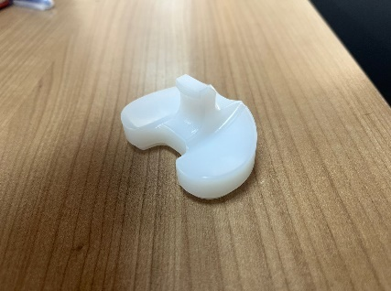

(Figure 2)

**Ceramics**

Ceramics are used in the medical sector for applications such as medical devices and thermometers. Some ceramics can also be used in applications like scaffolds and bone repair. However, due to their low fracture toughness, their use in the production of load-bearing products is limited.

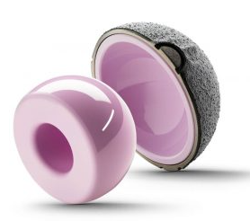.

(Figure 3)

**Composites**

Composites are widely preferred in the medical sector because they allow the combination of desired properties. Providing high strength with low density and weight, composites are frequently used in the production of implants.

(Figure 4)

**Natural Biomaterials**

There are new biomaterials derived from the plant and animal kingdoms. One of the most significant advantages of natural biomaterials used in implants is their ability to resemble tissues found in the body. These natural biomaterials are non-toxic and advantageous for tissue healing. However, the biggest problem with such biomaterials is that their structures can change under different environmental conditions. This significantly limits their use in the medical sector. (3)

**1.2 Factors to Consider in Material Selection**

Osseointegration, defined as the "direct structural and functional connection between living tissue and the surface of an implant under functional load," is one of the most critical factors in material selection for the medical sector. The success of implant treatment depends on selecting the appropriate material, the absence of mucosal inflammation and infection in the tissue where the implant will be placed, as well as the amount and quality of the bone surrounding the implant.

Therefore, the required properties of the material to be used are as follows:

* It must be compatible with surrounding tissues.
* It must be resistant to corrosion.
* It should not cause allergies.
* It must be durable against mechanical loads.
* It must be sterilizable.
* It should be easy to manufacture.
* It must be economical.
* Its structure should be homogeneous. (4)

**2) Device Calibrations**

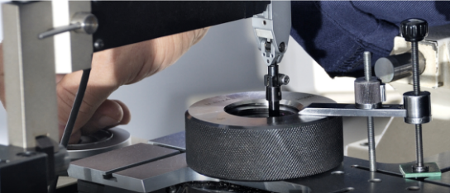

(Figure 5)

Calibration is the process of adjusting the measurement values of devices used for measurement and testing to align them with known standard tolerance ranges. Performing calibration at the right time and in an accredited manner is of great importance. Uncalibrated measuring devices can lead to incorrect results, damage reputation, and cause financial losses due to incorrect production or testing. As a result, undesirable outcomes such as reduced customer satisfaction and a decline in quality may occur.

For devices to be calibrated, factors such as material structure, frequency of use, and environmental conditions should be considered. Although the initial calibration date is hypothetical, subsequent dates should be adjusted and monitored according to the process. Devices experiencing issues should be checked during the process, and this situation should be recorded and evaluated. If a device provides results outside of tolerance, it typically indicates that the calibration interval needs to be shortened. While very short calibration intervals increase costs, extending the calibration intervals for devices that provide appropriate and repeatable data increases the risk of the device operating outside tolerance. Therefore, the optimum interval should be calculated.

The fundamental question in calibrating measuring devices is when calibration should be performed. Companies generally set specific dates or use statements such as "Micrometers will be calibrated every six months." However, even the same devices may require calibration at different intervals. For this reason, the calibration of measuring devices is critical to prevent sending products of undesirable quality to customers. (5)

**3) Machine Maintenance**



(Figure 6)

In industrial operations, machine failures, wear, and aging of components are common issues. These situations have made maintenance planning a mandatory activity. Especially since the 1950s, the importance of maintenance has increased, and maintenance approaches have evolved depending on industrial conditions. Maintenance encompasses activities aimed at preserving the functionality of machines and reducing breakdown costs.

Initially, maintenance was applied as corrective maintenance after failures. However, over time, it has been replaced by planned maintenance. Planned maintenance is divided into preventive maintenance and predictive maintenance. Preventive maintenance includes periodic lubrication and renewal processes, while predictive maintenance focuses on predicting failures based on measurement results. These approaches aim to enable businesses to maintain reliability and efficiency at low costs.

Since the 1970s, machine learning techniques have been used in maintenance planning. Machine learning, a system capable of learning from data and making predictions, has become an effective tool for optimizing maintenance planning in industry. This technique helps predict failures in advance, reducing maintenance costs and unexpected downtime.

Maintenance planning is critically important to prevent issues such as shipment delays, loss of prestige, and customer dissatisfaction. A proper maintenance strategy offers advantages such as timely correction of defective products and reduction of unnecessary maintenance expenses. (6)

**Total Productive Maintenance (TPM)**

Total Productive Maintenance (TPM) is a management approach that requires the participation of all employees, where operators are responsible for the autonomous maintenance of the machines and equipment they work with. It aims to prevent breakdowns and maximize equipment efficiency. This method was developed in 1971 in Japan by the Japan Institute of Plant Maintenance (JIMP). Based on the zero-defect philosophy of Total Quality Management, TPM offers a maintenance model that manages equipment with the goals of zero breakdowns and minimal production losses.

TPM is built on three fundamental concepts:

* Efforts to determine and improve equipment effectiveness,
* Autonomous maintenance processes performed by operators,
* Activities of small working groups organized for improvement purposes.

One of the most critical stages of this approach is measuring the current efficiency levels of equipment and implementing the necessary maintenance activities accordingly.

**Overall Equipment Effectiveness (OEE)**

One of the primary objectives of Total Productive Maintenance is to maximize the effectiveness levels of equipment within an organization. In line with this goal, Overall Equipment Effectiveness (OEE) is considered a crucial metric for determining the productivity levels of equipment. Businesses operating in the manufacturing sector report that they have succeeded in increasing the utilization rates of their existing assets through OEE analyses. OEE is an indicator that reveals how efficiently machines and facilities are utilized in businesses and plays a critical role in the success of lean manufacturing and Total Productive Maintenance practices. (7)

**4- Personnel Performance and Training**

In the medical sector, the performance, motivation, and training of personnel significantly impact the success of total quality management. The quality of services is directly influenced by the educational level, job satisfaction, and motivation of personnel. Therefore, in terms of ensuring the sustainability of product quality in the medical sector, continuous training and performance evaluations of personnel are of great importance.

**4.1 The Impact of Personnel Performance on Quality**

The job performance of personnel directly affects the quality of the products produced. High employee performance can reduce error rates, thereby improving product quality and enabling active participation in quality improvement processes. Various studies have shown that total quality management enhances employee performance and, consequently, increases product quality. (8)

**4.2 The Impact of Training on Quality**

Effective and regular training of employees ensures that production processes become more efficient, thereby leading to higher-quality products. The knowledge and skills of employees can be updated through various training programs, minimizing potential errors during the production process. Additionally, employees can be informed about necessary procedures or standards, improving the overall quality of the products. (9)

**4.3 The Impact of Occupational Health and Safety Practices**

Occupational health and safety practices play an effective role in ensuring that personnel work in a safe environment. A safe working environment is crucial for increasing employee motivation. Research has shown that occupational health and safety practices positively impact employee motivation and, consequently, improve product quality. (10)

**4.4 Performance-Based Payment Systems**

Performance-based payment systems are implemented to incentivize employees. They aim to increase employee motivation and job performance; however, designing this system correctly is crucial. Otherwise, undesirable outcomes such as loss of motivation and a decrease in job performance may be observed. (11)

**5- Total Quality Management and Continuous Improvement (Kaizen)**

Total Quality Management (TQM) is a type of approach used in the medical sector to improve quality. The fundamental elements of TQM include continuous improvement (Kaizen), customer focus, and employee involvement. TQM practices in the medical sector provide a framework for ensuring and enhancing the traceability of products on a continuous basis.

**5.1 Continuous Improvement**

Continuous improvement is one of the principles of Total Quality Management, aiming for the constant review and enhancement of processes. Through this approach, efficiency can be increased, and costs can be reduced. (12)

**5.2 Leadership and Management Support**

For Total Quality Management to be adopted, it is critical for top management to be committed to Total Quality Management. (13)

**5.3 Customer Focus**

Total Quality Management aims to improve quality by centering on customer needs and demands. In this way, customer satisfaction and loyalty are enhanced. (14)

**5.4 Process Management**

Total Quality Management aims to effectively manage and improve processes. In this way, process efficiency is increased, and the quality of products and services is enhanced. (15)

**6- Compliance with Regulations and Standards**

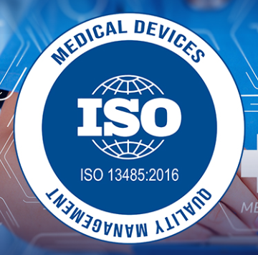

(Figure 7)

The production and use of medical devices must comply with national and international standards. These standards aim to ensure the safety and effectiveness of the products. Manufacturers in the medical sector are required to adhere to these standards and regulations and complete certification processes without any omissions.

**6.1 International Standards**

ISO 13485 is a standard established for quality management in medical devices. This standard aims to ensure and regulate the safety of production processes. Additionally, it promotes quality management in the design, manufacturing, and distribution processes of medical devices.

**6.2 Quality Management Systems**

ISO 13485 mandates that medical product manufacturers establish a quality management system. This ensures that products comply with specific quality standards.

**6.3 Risk Management**

ISO 14971 provides standards for managing risks throughout the lifecycle of medical devices. This standard enables the identification, recognition, and control of hazards in advance. (16)

**6.4 Compliance with Regulations**

In the European Union, the Medical Device Regulation (MDR) governs the requirements for the market introduction and clinical investigation of medical devices. MDR aims to enhance device reliability and performance. (17)

**6.5 Clinical Evaluation and Post-Market Surveillance**

MDR requires continuous monitoring and reporting of the performance, reliability, and clinical evaluations of devices. After the product is launched, it must remain safe and effective. (18)

**7- Patient Feedback and Clinical Outcomes**

Feedback obtained after the use of products provides essential information for quality improvement processes. Data such as patient satisfaction, complication rates, and the long-term success of products play a significant role in optimizing production and design processes.

**7.1 Patient Satisfaction Surveys**

In accordance with healthcare quality standards, surveys are conducted with patients. These surveys enable clinics and device manufacturers to see from the patients' perspective. Surveys focusing on patient satisfaction play a crucial role in improving quality. (19)

**7.2 The Impact of Clinical Outcomes on Quality**

* **Measurement of Clinical Quality:** Clinical quality is measured by evaluating patient observation, treatment processes, and care outcomes. These measurements are used to improve the quality of care. (20)
* **Turkey Clinical Quality Program:** Established in 2012, this program aims to monitor healthcare cases with a focus on processes and outcomes. (21)
* **Importance of Data Quality:** According to the 2019 Clinical Quality Feedback Reports, the biggest issue in clinical quality reviews is low data quality. This clearly demonstrates the importance of providing accurate and reliable data. (22)

**8- Supply Chain Management**

Supply chain management plays a significant role in ensuring product quality and patient safety. A well-planned and efficiently executed supply chain management process significantly impacts quality throughout the journey, from sourcing raw materials to delivering the final product to the patient.

**8.1 The Relationship Between Supply Chain Management and Quality**

Supply chain management involves the effective planning and control of the process from raw material acquisition to the production of the final product. Factors such as material quality, service quality, and supplier selection directly affect product quality. Collaborating with a reliable and high-quality supplier enhances the quality of final products. (23)

**8.2 Supplier Selection and Its Impact on Quality**

Choosing the right supplier is of great importance for product quality. In supply chain management, suitable suppliers are determined by considering quality criteria. Working with a reliable and accurate supplier leads to the production of higher-quality products. (24)

**8.3 Process Management and Efficiency**

A quality supply chain management system aims to enhance efficiency by optimizing processes. Efficient processes ensure the consistent and reliable delivery of products. (25)

**8.4 Customer Satisfaction and Quality Management**

A quality supply chain management system is crucial for improving customer satisfaction. High-quality products meet customer expectations, thereby increasing satisfaction levels. (26)

**8.5 Improvement and Innovation**

Continuous improvements in supply chain and quality management are essential. These improvements contribute to maintaining a competitive environment and producing higher-quality products. At the same time, they enable more effective responses to customer demands. (27)

**9) CAD-CAM Applications**

CAD refers to the use of computer assistance for creating and developing designs. CAM, on the other hand, refers to the use of computer interfaces for process planning, machine control, assembly, and quality control in manufacturing processes. Manufacturing with computer technologies can be controlled using CAD-CAM systems. Additionally, they provide convenience in various areas such as quality control, planning, and inventory tracking for businesses.

With CAD-CAM applications, the design process becomes faster, more standardized, and of higher quality. They are highly functional in generating two-dimensional technical drawings and three-dimensional models. Using CAD-CAM-supported CNC machines in production offers numerous advantages such as precision in manufacturing, time savings, and high-quality products. (28)

**10) Quality Control Processes**

Quality control refers to the techniques or processes applied to achieve a specific goal, purpose, or standard. Quality control processes include the identification, correction, and resolution of errors, as well as finding and addressing their root causes. Quality control operations began in the 1900s with the classification of final products as "good" or "bad." In the 1930s, the application of statistical quality control was introduced. Recognizing that inappropriate raw materials waste resources, input control processes were also given importance.

In the 1950s, the idea emerged that not only the production, inspection, and quality control departments but all departments should be responsible for quality control. This idea was named "Total Quality Control." Total quality control aims to meet consumer needs at the lowest cost. All employees in the company are responsible for detecting and correcting errors during production stages. In the 1960s, the concept of "company-wide quality control" was added to these ideas, making all departments and employees accountable for quality control. (29)

**11) Surface Smoothness and Osseointegration**

Biomaterials are the general term for natural or synthetic materials produced to perform or support the functions of living tissues in the human body. The biocompatibility of these materials enhances the healing process and success rate. Additionally, the surface smoothness of these products is crucial for a successful operation. A product with good surface smoothness has a much higher success rate in integrating or fusing with the body.

elektronik donanım, elektronik cihaz, ofis malzemesi, küçük alet içeren bir resim

Açıklama otomatik olarak oluşturuldu

(Figure 8)

Surface smoothness is expressed with the symbol 'Ra' and is measured using a "Profilometer" device. This device analyzes the surface's irregularities and smoothness at the micron or nanometer level. The value of surface smoothness varies depending on the process and its quality. Fundamental processes such as the size and shape of the sand used in sandblasting, spraying pressure, acid composition, and temperature in acid etching significantly affect the value of surface smoothness. (30)

**12) Product Sterilization and Cleanroom**

**12.1 Sterilization**

saydamlık, diyapozitif, iç mekan, plastik, zemin içeren bir resim

Açıklama otomatik olarak oluşturulduSterilization eliminates or inactivates viable microorganisms and pathogens on the product. It is divided into two categories: physical and chemical sterilization. The concept of sterility is an important quality element for all sterile materials, containers, and products. Sterility cannot be ensured solely through testing; therefore, it must be guaranteed under properly established production conditions. The sterilization method to be chosen should be evaluated according to the material, type, and intended use of the product.

(Figure 9)

**12.1.1 Physical Sterilization**

Physical sterilization methods are quite diverse, but the most common ones are pressurized steam, dry heat, and radiation sterilization:

* **Pressurized Steam Sterilization:**  
  The product is sterilized using heat and pressure in devices called autoclaves. In this method, materials that will not deteriorate under heat and pressure should be preferred. The process stages are: air removal, energy transfer by injecting steam, sterilization, steam evacuation, and drying.
* **Dry Heat Sterilization:**  
  It is carried out with a design fed by electrically heated air and consisting of an oven chamber to hold the load. It can be used for sterilizing many products.
* **Radiation Sterilization:**  
  This application, which is a terminal sterilization method, is carried out only with high-energy or ionizing radiation sources. The goal is to achieve sterilization with the lowest possible radiation level.



(Figure 10)

**12.1.2 Chemical Sterilization**

In chemical sterilization, gaseous substances that can be easily removed from the environment are generally preferred:

* **Hydrogen Peroxide:**  
  A strong oxidizer with broad-spectrum activity and a good safety profile. It is used for sterilizing filling lines and isolator systems. Its advantages include being environmentally friendly, less hazardous than other chemicals, and not requiring ventilation. However, it is not suitable for liquid sterilization.
* **Ethylene Oxide:**  
  It is a toxic gas and is used only when no other sterilization method is possible. It should be applied carefully as it may alter the structure of certain products.

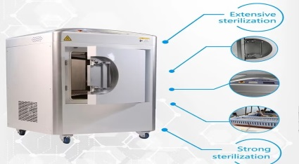

(Figure 11)

* **Ozone:**  
  When decomposed, it releases an oxygen molecule and an oxygen radical. This radical disrupts the cell structure of some microorganisms, causing cell death. In some industrial applications, it is placed in the sterilization chamber for sterilization purposes.
* **Chlorine Dioxide:**  
  It is a gas at room temperature and is produced on-site due to its reactive nature. It cannot be stored or preserved under high pressure. It is used for sterilizing stainless steel products. (31)

**12.2 Cleanroom**

To obtain a sterile product, the production environment must meet standards. Therefore, cleanrooms are specially constructed. The air conditioning and filtration systems of cleanrooms should be designed to maintain sterility. It is also important that cleanroom workers wear appropriate clothing and that the tools and equipment used comply with the room conditions. (32)

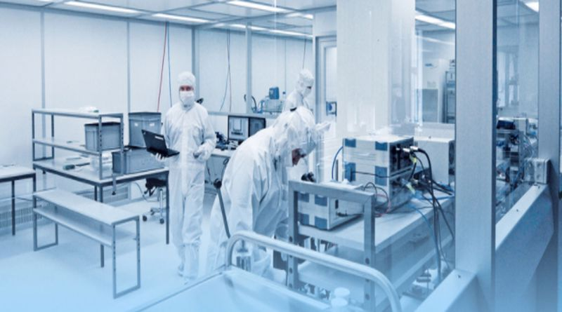

(Figure 12)

**13) Environmental Hygiene**

Hygiene is a concept encountered in many aspects of human life and is of great importance for human health. In general, hygiene is a field of science that includes and applies health-related knowledge for the protection and improvement of environmental and human health. In the medical sector, hygiene plays a crucial role in the production process and directly impacts quality. The primary reason for this is to prevent complications that may occur when the produced products are placed into the human body. Various precautions are taken in this regard.

**13.1 Personnel Hygiene**



(Figure 13)

Personnel hygiene is vital for ensuring ideal hygiene conditions in medical production processes. Illnesses, carelessness, and negligence among personnel can compromise the hygiene standards of the products produced. Therefore, personnel must adhere to cleanliness rules and use personal hygiene equipment. Personnel should wear items such as hair caps, gloves, goggles, masks, and aprons.

**13.2 Equipment and Material Hygiene**

Businesses producing medical products must be meticulous in equipment selection. The equipment used should be made of cleanable materials and must be cleaned and disinfected after each use.

**13.3 Equipment and Material Disinfection**

In businesses producing medical products, equipment and tools should be regularly cleaned and disinfected under the supervision of expert personnel. This ensures that the products manufactured are more hygienic and healthy.

**13.4 Workplace Hygiene**



(Figure 14)

Workplace hygiene encompasses the areas where medical products are produced, stored, and offered for sale. These areas should be regularly ventilated, cleaned, and disinfected as necessary. (33)

**14) R&D Activities**

In today's competitive market, it is essential for businesses to develop new products that meet consumer demands in order to survive. To succeed, it is necessary to create high-quality, innovative, and practical products. Innovation provides businesses with a competitive advantage by offering new benefits to customers.

For medical product manufacturers in Turkey to reach the level of developed countries, they need to focus on developing innovative products and differentiation. In this context, R&D activities, which are systematic and creative efforts aimed at introducing new products and production processes, are becoming increasingly important.

R&D activities, which demonstrate their impact on both micro and macro levels, are gaining popularity as an influential factor in economic and technological development. (34)

**15) Logistics**



(Figure 15)

The term logistics originates from the French language. Logistics can be defined as the management and coordination of all material-based functions related to the production and distribution of a product or service. The goal is to make the organization resilient against vital market variables such as quality, price, time, and service, ensuring the company's survival.

**15.1 Production Planning**

Production planning is closely related to topics such as quality management, manufacturing schedules, layout arrangements, resource planning, monitoring work in progress, and providing support during the process.

**15.2 Material Management**

Material management plays a critical role in the production, tracking, and procurement processes of products consisting of hundreds of parts. ERP (Enterprise Resource Planning) and MRP (Material Requirements Planning) systems are frequently used in these processes.

**15.3 Inventory Management**

Inventory management can be considered a subcomponent of material management in manufacturing enterprises. It includes processes such as inventory control, reducing storage costs, maintaining stock levels, and managing losses and damages.

**15.4 Storage and Material Handling**

Safety, protection, and cost factors are taken into account during the handling and storage of materials. Packaging and wrapping of materials are also part of these processes. There is continuous "material movement" both within and outside the business.

**15.5 Distribution**

Distribution activities control the inbound and outbound traffic of warehouses. It is crucial for establishing communication between the business and customers and ensuring just-in-time (JIT) operations. All members involved in distribution, such as intermediaries, wholesalers, dealers, and retailers, have specific responsibilities and roles in delivering final products to buyers.

**15.6 Warehouses and Depots**

Warehouses and depots are critical to logistics activities, including the location, capacity, operation, and suitability of distribution centers and storage areas for operations.

**15.7 Transportation**

Key elements of logistics include the identification of goods to be transported, transportation under appropriate conditions, shipment and operation management, and time planning.

**15.8 Insurance**

Both transported and stored goods, as well as factors such as vehicles and drivers, must be insured for protection.

**15.9 Customs Services**

Customs clearance services are an integral part of import and export operations in international transportation.

**15.10 Customer Services**

Demand forecasting, service levels, order methods, spare parts, technical support, and after-sales services are highly important in logistics processes.

**15.11 Technical Support**

To ensure the smooth execution of operational activities, technical support must be provided, and necessary systems must be established.

**Logistics Management**

Logistics management aims to deliver the right product to the right place at the right time (JIT - Just in Time). This management creates value in terms of place and time for products and services, playing a significant role in production processes and the delivery of exported goods. (35)

**16) Inspection and Testing**

Inspection and testing are highly important activities for ensuring quality assurance and the production of high-quality products. The product must be inspected at three stages.

* The first stage involves the inspection of incoming raw materials and other supplies.
* The second stage is the inspection during the production process, before the product is completed.
* The third stage is the final inspection and testing of the finished product.

These three stages are crucial for influencing quality and preventing the release of defective products. (36)

**17) Certification**

Certification serves as a mechanism to document the compliance of a product, process, or service with national and international standards, having a critical impact on quality. This process, which ensures adherence to standards, enhances production efficiency through early error detection, process improvements, and effective resource utilization.

Certificates not only strengthen customer trust and satisfaction but also provide businesses with legal compliance and a competitive advantage in international markets. For example:

* **ISO 9001** ensures the orderly execution of quality management systems,
* **CE** and **FDA** certifications support the reliability and global acceptability of products.

Additionally, certification processes encourage employee participation, enhancing the effectiveness of quality management systems and directing businesses toward a cycle of continuous improvement.

Within this framework, certification guarantees quality across various domains, from customer satisfaction to environmental sustainability, contributing to businesses achieving a reliable, efficient, and competitive structure. (37)

**18) Traceability**

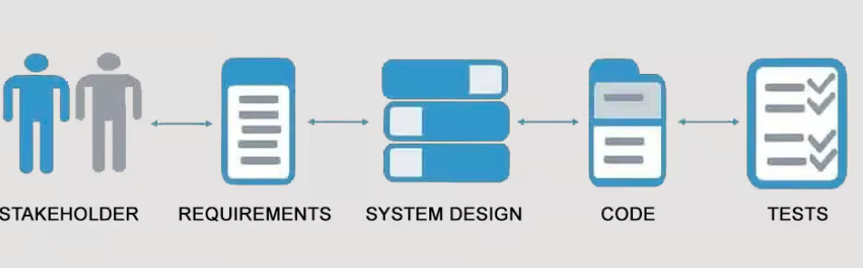

(Figure 16)

Traceability stands out as a critical element in the medical sector, enhancing quality. Recording and monitoring all processes from production to consumption facilitate quality control and make error management highly effective. With traceability, the source of errors in a product or process can be quickly identified, corrective measures can be taken, and patient safety, product reliability, and cost reduction are achieved.

Additionally, traceability offers significant advantages in complying with regulations; these systems support meeting legal requirements and conducting audits successfully. In cases of defective products, traceability systems enable more efficient and cost-effective recall processes.

Transparency in the supply chain and the prevention of counterfeit products are also ensured through traceability, directly contributing to quality in the medical sector.

**19) Clinical Collaboration and Survey Studies**

Clinical collaboration and survey studies are significant methods that directly impact quality in the medical sector. Clinical collaboration fosters the sharing of knowledge and experience among healthcare providers, researchers, and medical product manufacturers, enabling the development of products and services with a patient-centered approach. Through this collaboration, the effectiveness, reliability, and ease of use of devices and drugs utilized in treatment processes can be more accurately assessed.

Survey studies, on the other hand, identify patient satisfaction, needs, and complaints directly, helping to pinpoint areas for improvement. Feedback obtained from surveys aids in making data-driven decisions during product development processes and enhances service quality.

Both methods play a critical role in continuously improving patient safety, satisfaction, and product-service quality, thereby elevating the overall quality standards in the medical sector.

**20) Use of Technology**

Digitalization and smart technologies are driving significant transformations in the medical sector in terms of quality management, patient satisfaction, and operational efficiency. Technologies such as electronic health records, smart sensors, and artificial intelligence enable processes to be carried out faster, more reliably, and more cost-effectively. Additionally, telemedicine and remote monitoring solutions enhance patient care while improving accessibility.

However, the adoption of these technologies also brings challenges such as data security, costs, and resistance from personnel. With proper planning and training, these barriers can be overcome, allowing digitalization to contribute to quality improvement by offering innovative solutions in the sector.(38)

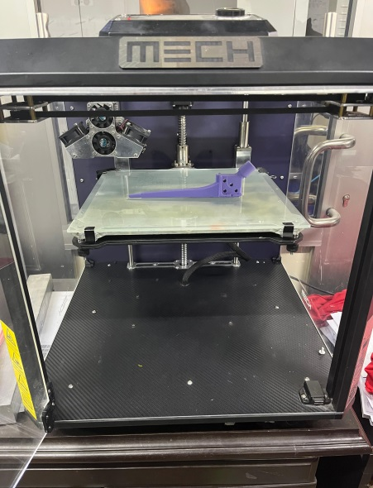

(Figure 17)

**METHOD**

**Use and Definition of the Relation Scale**

In this study, a relation scale was used to evaluate the interactions between factors and their impact on the analysis results. The scale is numbered from 0 to 4, with each number defined as follows:

* **0: No influence**  
  Represents situations where the relevant factor has no effect on the other factor.
* **1: Very low influence**  
  Indicates situations where the relevant factor has a very low level of influence on the other factor.
* **2: Normal influence**  
  Denotes a standard relationship where the influence of factors on each other is at a moderate level.
* **3: High influence**  
  Represents cases where the relevant factor has a significant and high impact on the other factor.
* **4: Very high influence**  
  Reflects situations where the interaction between factors is very strong and at a high level.

This scale was used to transform the qualitative analysis of the data into a quantitative structure. The values in the table were determined based on expert opinions or modeling results and were utilized during the analysis process.



**Table 1: Influencing and Influenced Criteria Matrix**

This table was created based on evaluations conducted jointly by four experts (2 quality management engineers, 1 quality assurance engineer, and 1 planning engineer). The experts scored the relationships between the criteria on a scale of 0-4 (0: No influence, 4: Very high influence).

* **Influencing Criteria**: Listed in the left column, representing factors that influence others.
* **Influenced Criteria**: Listed in the top row, representing factors that are influenced by others.

Total scores were calculated for each criterion as both influencing and influenced. This approach provided a foundational dataset for visualizing and analyzing the relationships between criteria.

**Table 2: Normalized Relation Matrix**

This table was created by normalizing the values from the previous table. The normalization process involved dividing each value by the largest value derived from the sum of the rows and columns. This method ensures the scaling of the data, making the relationships between criteria more objective and comparable. The normalized values provide a better understanding of the relative weights of the interactions between the criteria.

**Table 3: Identity Matrix and I,(I-M) Matrix**

Identity Matrix: The identity matrix is a square matrix where all diagonal elements are 1, and all other elements are 0. It is used as a reference in the analysis.

******I−M Matrix:** The I−M matrix is obtained by subtracting the identity matrix (I) from the normalized relation matrix (M). This operation highlights the interactions between the criteria and deviations from the identity structure.

**Table 4: (I−M)^−1 Matrix**

This table was created by taking the inverse of the I-M matrix ((I−M)^−1

Purpose: The (I−M)−1matrix is used to calculate the total of direct and indirect effects between the criteria. This method allows for a detailed analysis of all



**Table 5: Total Relation Matrix**

This table was created by multiplying Table 4 ((I−M)^−1with the normalized relation matrix (M).

Total D : The "Total D" column represents the sum of each row and shows the total impact a criterion has on other criteria. This value reflects the influencing power of the criterion within the system.

Total R : The "Total R" row represents the sum of each column and shows the total impact a criterion receives from other criteria. This value indicates the dependency of the criterion on the system.

**Table 6:** **Identification of Importance Weights**

This table was created starting from the total impact (Total D) and total response (Total R)values, followed by a series of mathematical operations to determine the final percentage importance weights (Wi).The steps are as follows:

**Total D and Total R Values**: These values were taken from the previous table.

Total D: Indicates the total influence of each criterion on others.

Total R: Indicates the total influence each criterion receives from others.

**D+R and D-R Values**:

**D+R**: Calculated by summing Total D and Total R. This value represents the total interaction of a criterion within the system (as both influencing and influenced).

**D-R**: Calculated by subtracting Total R from Total D. This value shows whether a criterion is dominant (influencing) or dependent (influenced) within the system.

**Wai Value**:

**Calculation**: The square of D+R and D-R were taken, and their sum's square root was calculated to obtain the Wai value:

This value measures the overall importance of each criterion.

**Wi (Final Percentage Weights)**:

**Calculation**: The total sum of all Wai values was calculated. Each Wai value was then divided by this total to determine the percentage weights (Wi):

x100

**Conclusion**: The Wi percentage values represent the importance weights of each criterion within the system. This calculation method provides a comprehensive evaluation by considering both direct and indirect interactions.

**Medical Sector Quality Influencing Factors and Their Weighting**

In this study, the factors influencing quality in the medical sector were analyzed and weighted using the DEMATEL (Decision Making Trial and Evaluation Laboratory) method. The results highlight the relative importance of each factor in determining and maintaining quality standards. The calculated percentages represent the contribution of each factor to overall quality management.

The top influencing factors include "Compliance with Regulations and Standards" (7.02%), "TQM and Continuous Improvement (Kaizen)" (6.92%), and "Quality Control Processes" (5.92%), indicating their critical roles in ensuring quality. These factors emphasize the importance of adherence to standards, continuous improvement practices, and effective control mechanisms in the medical sector.

Other notable factors, such as "Material Selection and Biocompatibility" (5.47%), "Surface Smoothness and Osseointegration" (5.43%), and "R&D Activities" (5.27%), highlight the technical and research-oriented aspects that influence quality outcomes.

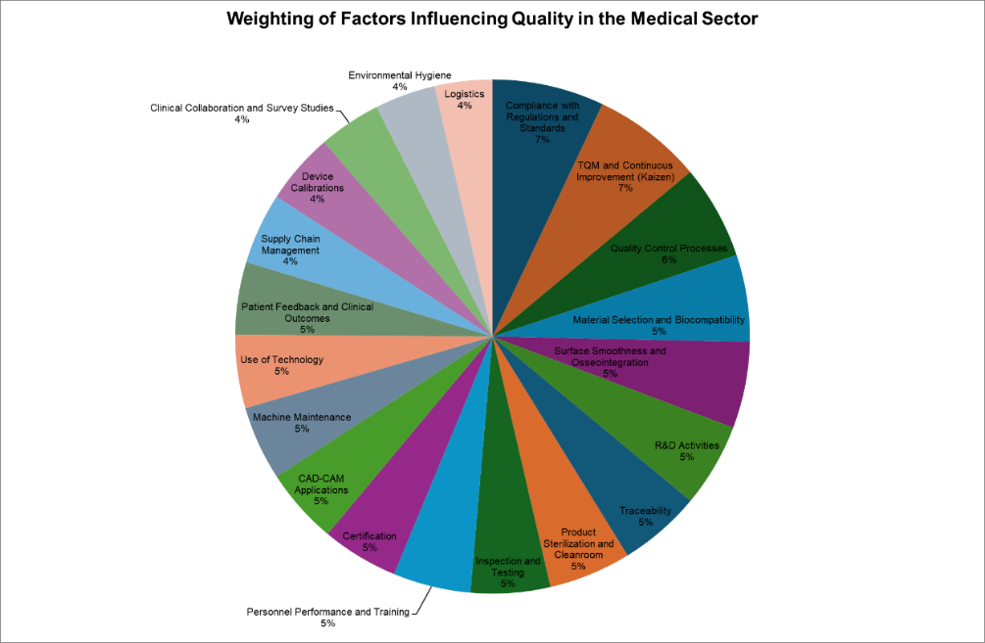Factors like "Logistics" (3.63%) and "Environmental Hygiene" (3.81%) were weighted lower, suggesting they have less direct but still meaningful influence on quality when compared to other criteria.

**CONCLUSION**

The quality of the medical sector is influenced by a complex interplay of technical, operational, and regulatory factors. This study used the DEMATEL method to identify and weight these factors, providing a structured framework for understanding their relative importance. Key findings underscore the critical roles of compliance with regulations and standards, Total Quality Management (TQM), and quality control processes. These factors emerged as pivotal in ensuring the safety, effectiveness, and reliability of medical products and services.

Additionally, technical factors such as material selection, biocompatibility, and surface smoothness significantly contribute to product performance and patient outcomes. The emphasis on R&D activities highlights the importance of continuous innovation in addressing evolving healthcare needs.

Operational aspects, including personnel training, machine maintenance, and supply chain management, also play essential roles, albeit with varying degrees of influence. These findings suggest that a holistic approach to quality management—encompassing regulatory compliance, technological advancements, and operational efficiency—is vital for sustaining and enhancing quality in the medical sector.

Ultimately, this study provides actionable insights for policymakers, healthcare providers, and manufacturers. By prioritizing the identified factors, stakeholders can drive improvements in quality management systems, ensuring better patient safety and satisfaction while maintaining operational efficiency and cost-effectiveness. Future research could expand on these findings by exploring the dynamic interactions among factors in diverse healthcare settings.

**REFERENCES**

Figure 1

Figure 2

Figure 4 Zimed Medikal

Figure 9

Figure 17

Figure 3 = <https://erdembagatur.com/total-kalca-protezi/total-kalca-seramik-protez/>

Figure 5=<http://egemet.com.tr/>

Figure 6= <https://www.2bmekatronik.com/>

Figure 7 = <https://www.elecrow.com/blog/what-is-iso-13485.html>

Figure 8= <https://www.infotek.com.tr/portatifyuzeypuruzlukolcumcihazlari.htm>

Figure 10=https://farmakod.com/cozum/gama-isin-tesisleri-projeleri

Figure 11 = <https://tr.made-in-china.com/co_aucmamedical/product_Ethylene-Oxide-Sterilizer-Eto-Sterilization-Machines-80-Liters-120-L-Plasma-Sterilizer_yshiogsgyg.html>

Figure 12 = <https://www.belge.com/laboratuvar/uygunluk-testleri/temiz-oda-testleri/>

Figure 13= <https://tr.wanli-safety.com/info/why-is-a-cleanroom-suit-necessary-91115611.html>

Figure 14=(https://www.rubbermaidcommercial.com.au/blog/healthcare/from-floor-to-ceiling-maintaining-environmental-hygiene-in-hospitals/ )

Figure 15= <https://sic-productions.com/what-is-logistics-management/>

Figure 16= <https://t2informatik.de/en/smartpedia/traceability/>

1=Name of Modern Management: Total Quality Management Ümmühan GÜLNAR Yönetim ve Organizasyon/Yerel Yönetimler Bölümü Kadınhanı Faik İçil MYO Selçuk Üniversitesi <https://dergipark.org.tr/tr/download/article-file/3280774>

2= https://dergipark.org.tr/tr/download/article-file/3546136?utm_source=chatgpt.com

3-Types of Biomaterials and Biocompatible Metallic Elements BSEU Journal of Science <https://doi.org/10.35193/bseufbd.1165914>

4-Dental Implant Materials Nilüfer Çelebi Beriat, Gülşah Gülay, Ahmet Atila Ertan

<https://dergipark.org.tr/tr/download/article-file/1079893>

5=ÖLÇÜM CİHAZLARINA AİT KALİBRASYON PERİYOTLARI İÇİN RİSK ANALİZİ İNCELEMESİ VE KARAR DESTEK SİSTEMİ TASARIMI <https://dergipark.org.tr/tr/download/article-file/1066809>

6=Bakım için makine öğrenme tekniklerinin analizi ve bir uygulama <https://dergipark.org.tr/tr/download/article-file/1679448>

7=TOPLAM VERİMLİ BAKIM VE EKİPMAN ETKİNLİĞİ: BİR İMALAT İŞLETMESİNDE UYGULAMA <https://dergipark.org.tr/en/download/article-file/62613>

8-Sağlık Kurumlarında Toplam Kalite Yönetimi ve Personel Performansı Üzerine Etkisi – Dergipark <https://dergipark.org.tr/tr/download/article-file/1476280>

9-Eğitim Uygulamalarında İnsan Kaynaklarının Kaliteye Olan Etkisinin Değerlendirilmesi – NEU <https://docs.neu.edu.tr/library/6916042425.pdf>

10-Kamu Hastanelerinde İş Sağlığı ve Güvenliği Uygulamalarının İş Performansına Etkisi – Dergipark <https://dergipark.org.tr/tr/download/article-file/743962>

11-Performansa Dayalı Ek Ödeme Sisteminin Hastane Hizmet Kalitesine Etkisi – Dergipark <https://dergipark.org.tr/tr/download/article-file/738495>

12-Acar, D. (2016). Kaizen Felsefesi ile Toplam Kalite Yönetiminin Verimlilik ve Maliyet Üzerine Etkisi. Alanya Akademik Bakış Dergisi, <https://dergipark.org.tr/tr/download/article-file/349108>

13-Yıldırım, H. (1999). Toplam Kalite Yönetiminin Firmaların Rekabet Güçleri Üzerindeki Etkileri. Yayımlanmamış Yüksek Lisans Tezi, Marmara Üniversitesi Sosyal Bilimler Enstitüsü. <https://dergipark.org.tr/tr/download/article-file/953698>

14-Kazan, H., Değermen, A., & Yurtman, G. G. (2017). Toplam Kalite Yönetiminin İç ve Dış Müşterilerin Performans Değerlendirmesi Üzerine Etkisi. Yönetim ve Ekonomi Araştırmaları Dergisi, <https://dergipark.org.tr/tr/download/article-file/265519>

15-Demir, A., & Yılmaz, E. (2022). Toplam Kalite Yönetimi, Kaizen ve Entegrasyon Süreçlerinin Bütünleşik Etkisi. Niğde Ömer Halisdemir Üniversitesi İktisadi ve İdari Bilimler Fakültesi Dergisi, <https://dergipark.org.tr/tr/download/article-file/3539276>

16=ISO 13485 Standardı: Medikal Cihazlarda Kalite Yönetim Sistemi. Medikal Kalite, 2023. <https://www.medikalkalite.com/iso-13485--medikal-cihaz-uretiminde-kalite-ve-guvenligin-standardi/>

17=Avrupa Birliği Medikal Cihaz Regülasyonu (MDR) 2017/745. Medikal Kalite, 2023. <https://www.medikalkalite.com/mdr-2017-745/>

18=PSUR ve PMCF Raporları ile Klinik Değerlendirme. Tıbbi CE, 2023.

<https://www.tibbice.com/psur-pmcf-trend-raporu-mdr/>

19=Sağlıkta Kalite Standartları ve Anket Uygulamaları. DergiPark, 2023. <https://dergipark.org.tr/tr/pub/spkd/issue/73405/1029801>

20=Klinik Kalite ve Göstergelerin Değerlendirilmesi. DergiPark, 2023. <https://dergipark.org.tr/en/download/article-file/1413555>

21=Türkiye Klinik Kalite Programı. Sağlık Bakanlığı, 2023. <https://kalite.saglik.gov.tr/Eklenti/11097/0/03kkhpdf.pdf>

22=Klinik Kalite Verilerinde Doğruluk ve Güvenilirlik. DergiPark, 2023. <https://dergipark.org.tr/tr/pub/spkd/issue/69860/830829>

23=Özdemir, A. (2004). Tedarik Zinciri Yönetiminin Gelişimi, Süreçleri ve Yararları. Erciyes Üniversitesi İktisadi ve İdari Bilimler Fakültesi Dergisi, (23), 1-16. <https://dergipark.org.tr/tr/pub/erciyesiibd/issue/5880/77809>

24=Güzel, L., & Sayan, İ. (2023). Toplam Kalite Yönetiminin Tedarik Zinciri Yönetimi Üzerindeki Etkisi. Verimlilik Dergisi, 7, 533-548 <https://dergipark.org.tr/tr/pub/verimlilik/issue/79212/1221956>

25=Akkuş, S. (2017). Tedarik Zinciri Yönetimi Modellerinin İşletmelere Uygulanabilirliği. Yüksek Lisans Tezi, Maltepe Üniversitesi Sosyal Bilimler Enstitüsü. <https://openaccess.maltepe.edu.tr/entities/publication/003ee048-168f-42f4-a381-3252880c79e0>

26=Saru, M. (2015). Altı Sigma Yaklaşımı ve Tedarik Zinciri Yönetiminde Uygulaması. Yüksek Lisans Tezi, Yalova Üniversitesi Fen Bilimleri Enstitüsü.

27=Bayhan, M. (2022). Üretim Süreçlerinde İstatistiksel Kalite Kontrolü Uygulamaları Üzerine Bir Araştırma. <https://dergipark.org.tr/tr/pub/yenifikirjournal/issue/71498/1126280>

28=Electronic Letters on Science & Engineering 14(3) (2018) Production Process on CNC Machines Dr. Öğr. Ü. Mustafa YAZ, Tuğba BOZKURT <https://dergipark.org.tr/en/download/article-file/587300>

29= QUALITY CONTROL AND TOTAL QUALITY CONTROL APPLICATIONS IN THE WORLD (PART I) <https://dergipark.org.tr/tr/download/article-file/218352>

30= TOTBİD Dergisi.Improving the surface characteristics of the implant materials. Hasan Havıtçıoğlu <https://dergi.totbid.org.tr/uploads/pdf_230.pdf>

31= Sterilization of Pharmaceutical Products Journal of Medical Sciences 2022, 3(4) 199-205 <https://dergipark.org.tr/tr/download/article-file/2843372>

32= TEMİZ ODALARIN TASARIMI İstanbul Ticaret Üniversitesi Fen Bilimleri Dergisi Yıl: 8 Sayı: 15 Bahar 2009/1 s.37-54 <https://dergipark.org.tr/tr/download/article-file/199543>

33= İSTANBUL’DA BAZI GIDA İŞLETMELERİNDE HİJYENİK KALİTENİN SAPTANMASI. Muhammed Ali GÖKTAŞ <https://tez.yok.gov.tr/>

34= ÜRETİM İŞLETMELERİNDE ÜRÜN (MAMUL) GELİŞTİRMENİN AR-GE DEPARTMANINDA TEKNİK AŞAMALARI VE BİLGİ TEKNOLOJİLERİNİN KULLANIMI <https://dergipark.org.tr/tr/download/article-file/1869759>

35= Lojistik Faaliyetlerin Yönetimi ve Maliyetleme Yaklaşımları İlker KIYMETLİ ŞEN İktisadi ve İdari Bilimler Fakültesi Dergisi Y.2014, Cilt 4, Sayı 1, ss.83-106 <https://dergipark.org.tr/tr/download/article-file/382289>

36= İstanbul Üniversitesi Sosyal Bilimler Enstitüsü İşletme Fakültesi.Kalite Sistemi ve Bir Uygulama <https://nek.istanbul.edu.tr/ekos/TEZ/24598.pdf>

37= 1)ISO. (2023). *ISO 9001: Quality Management Systems Requirements*. Geneva: International Organization for Standardization. <https://www.iso.org/standard/62085.html>

38= Global strategy on digital health 2020-2025 . ©️ World Health Organization 2021 https://iris.who.int/bitstream/handle/10665/344249/9789240020924-eng.pdf?sequence=1&isAllowed=y